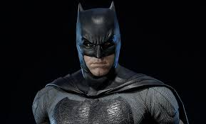

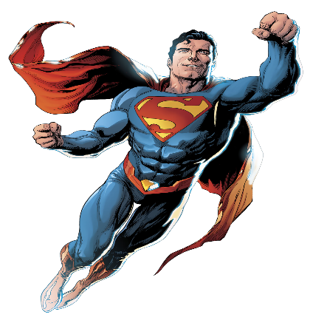
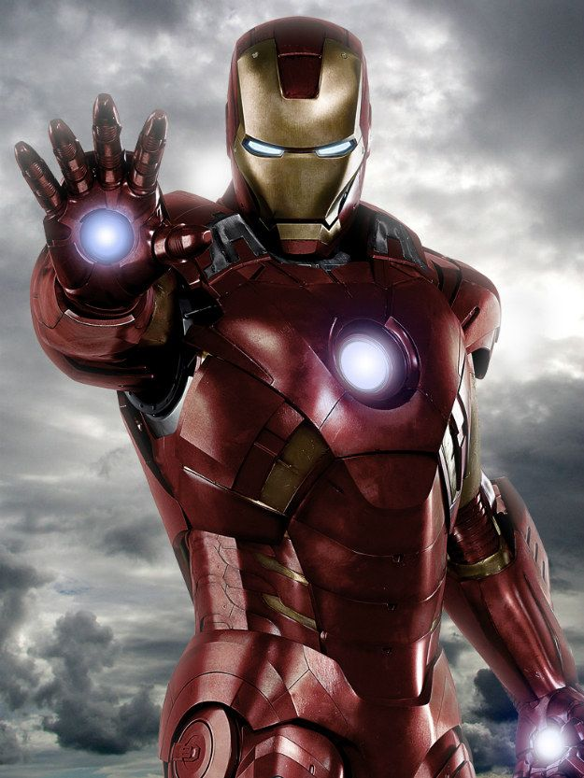

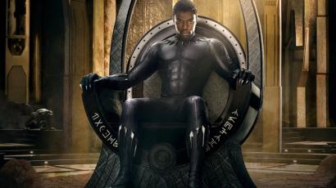
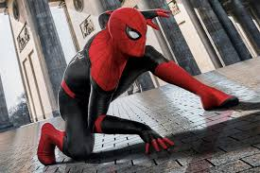
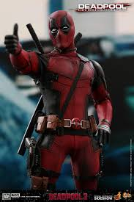
   

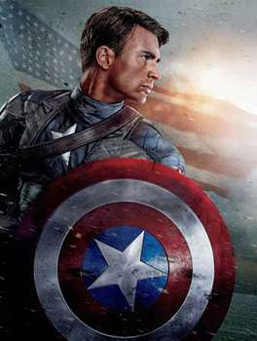

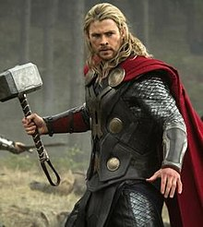

Look at the attached pictures, re-attach each picture beside the paragraph it suits. Then, justify why you think that is applicable.

There's a pretty good chance at least some are already working for you, so make certain to acknowledge them.


Every successful business has a cadre of secret superheroes. These are the people who make things happen, get things done and inspire others with their innovation and foresight.
Many of these everyday champions are hiding in plain sight -- they could be almost anyone. Their superpowers are the skills and talents your company needs to go from ordinary to extraordinary faster than a speeding bullet.
So, if you’re hoping to Hulk-smash the competition and take your business to new heights, make sure you include these eight superheroes in your planning.
This person is your company’s fearless leader. Their main superpower is radiating charismatic charm and con dence while being able to spot inef ciencies and conceptualize solutions to x them. This superhero is the pragmatic and team-enabling commander. He or she is known for being inspiring, direct, honest and consensus-driven.
A superhero who examples this leadership style is T’Challa, The Black Panther. He un achingly accepts challenges and works to overcome any obstructions or complications that come his way. But even as he takes on foes, he’s focused on working toward goals that help the greater good.
Companies with a Black Panther superhero have leaders who excel at asserting themselves, who are compassionate but have a "trust-but-verify” style of decision making. Just keep in mind that, while these leaders are great at getting things done and rallying the troops to work on a common goal, they may nd it dif cult to tap into their feelings and may overlook their own emotions.
While everyone else in your company has their heads down, working hard on day-to-day challenges, you need someone who is thinking ahead and dreaming big. Having a senior leader who focuses on the big picture, on seeing new possibilities and creating the next big thing, is absolutely essential to your company’s success.
This superhero is someone who breathes innovation, creativity and ingenuity. His or her talents are key to staying ahead of competitors and being ready for any disruptions that are coming your way. Even more importantly, this person will help you carve out your company’s unique mission and objective. The innovator/visionary leader is the superhero who helps your company stand out and
shine, as opposed to just trying to keep up with competitors.

This excellent problem solver is the Tony Stark/Iron Man of your company. These types of leaders are often known for their wit and boundless ideas. However, they may also be rash and outspoken at times. Just as Stark is constantly pushing the limits of technology to improve his capabilities and rise to greater challenges, this kind of leader is an inventive genius who is often gifted in science and math.
away so he can completely focus on those projects.

Like Stark, these people can create wave after wave of disruptions, even as others try to appropriate their genius ideas for their own purposes. While Stark is known for his likable demeanor and using humor and wit, when he’s “in the zone” and working on innovations, he’s known to shut himself You need this superhero in your ranks because this person has a passion for making the world a better place and will bring a sense of moral purpose to your company. They are exceptional communicators, deeply creative and always guided by principles and a strong sense of altruism.
If their talents can be effectively harnessed, they can bring a deep and empathetic understanding of your customers’ needs and wants. This superhero can be great at marketing because they have the uncanny ability to see themselves in the customer’s shoes.
Like Peter Parker/Spider-Man, this superhero has a strong sense of right and wrong. This type of person can make a skilled mediator and is good at creating win-win situations. He or she may be the geeky, quiet, behind-the-scenes hero who is incredibly skilled at perceiving and sensing the world around them. Spider-Man types can be an amazing force for good, and they do their best work when their professional life aligns with their values.
This superhero plays the role of the fearless, get-stuff-done energetic powerhouse. They are perfect for taking big plans and putting them into action. They’re great team players and excellent at running meetings because they tend to stay focused and on task. These superheroes are doers at heart -- friendly, adaptable and always moving quickly to accomplish goals.
Doers are like Wonder Woman: fearless yet compassionate, and unafraid to take control of a situation. They get to the point quickly and have high standards of performance for themselves, while expecting the same of others. They’re results-oriented and great at coming up with shortterm action plans. They’re also loyal to their peers and have excellent people skills.
This superhero’s main power is the discipline and objectivity that will help your company put its plans into action. They’re practical, realistic and dependable, with a take-charge attitude that be ts a leadership position. But they aren’t “yes” people. As a director, this superhero will give you his or her honest opinion -- no holds barred.
Like Thor, this leader has no problem putting down the hammer when necessary. And just like the Asgardian god of thunder, these everyday business heroes remain calm, capable and supremely con dent under pressure. With strong moral values and a sense of duty and tradition, they can
seem in exible and arbitrarily stubborn. They may become critical of those they believe are falling short.

Thor-style leaders are skilled at making objective and impersonal decisions. They value facts and logic, and seek to come to rational conclusions. They excel at working on concrete, tangible projects with a well-de ned reward, and they excel in jobs that require high levels of productivity and organization. Their boisterous, energetic attitude makes them generally well-liked and appreciated.
This superhero may come off as somewhat annoying, as they’re the ultimate devil’s advocate. Their superpower is their ability to debate and question anything and everything. They thrive on mental sparring and enjoy shredding other people’s arguments and convictions.
Think of this perpetual debater as your of ce Deadpool antihero. They aren’t the normal superhero type, and they probably don’t like to play by other people’s rules, but they offer important insights your company needs. Like Deadpool, debaters can be witty, but their constant counterarguments can be vexing at times. Still, businesses need this persona to give them the opposing view, to spot the weaknesses in their systems and plans, and to drive the team forward in new ways.
This unconventional hero is intellectually curious and loves challenging problems. Their natural ingenuity makes them a great t for entrepreneurial jobs. They can be great at driving planning sessions and brainstorming new concepts. They love being the underdog and they’ll always question prevailing thinking, making them irreplaceable when reworking systems or trying to shake things up.
This creative and conscientious superhero is skilled at long-range thinking and excels when
working independently. Perhaps the most amazing talent of this type of superhero is uncanny foresight for what products or ideas will be relevant now and in the future. Don’t let their quiet
exterior fool you; they can spot trends early on, and they have an impressive ability to predict how a situation will turn out.
This of ce superhero is like Batman: a reserved, independent-minded person who is compassionate and idealistic, but also logical and constantly searching for patterns and explanations. Batman is always spotting details other people have overlooked, and he understands and empathizes with the average citizen. Similarly, this real-life business hero can connect with and discern customer needs.

This type of superhero can make a great advocate, as they have a strong intuition and they desire to know and understand those around them on a deeper level. Their empathic and thoughtful nature makes them well suited to connecting with others and understanding what people desire. They’re perfectionists, but they can also be amazing strategic and long-range planners.
This superhero is motivated to help make the world a better place and take care of others. They’re loyal and sel ess, driven to be of service. In a company, they are warm, practical, organized and good at listening to others, making them great team members. However, they may take criticism personally, and they don’t always handle con ict well.
This person is the Captain America of your of ce. They’re naturally humble and unassuming, and tend to adhere to structure and authority. Their empathy, authenticity and high emotional intelligence make them skilled at social networking and connecting with others.
Like Captain America, this of ce superhero will always have his or her team’s back. They will shun the limelight while helping to build others up and putting in the hard work to help everyone meet
their goals. But they’re rule followers at heart, and may disapprove of those who question authority or go against precedent.

